**To Connect a Windows EC2**

**Step-1 after successfully creating instance click on 🡪view all instance**

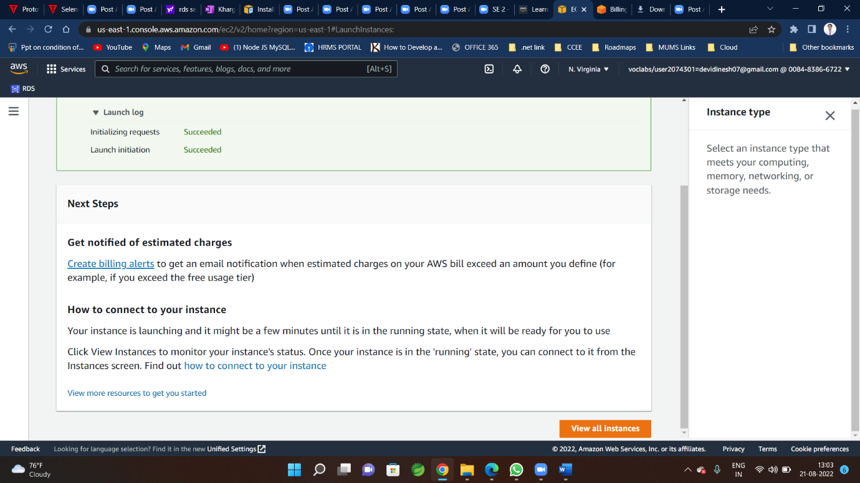

**Step-2 you are redirected to this window**

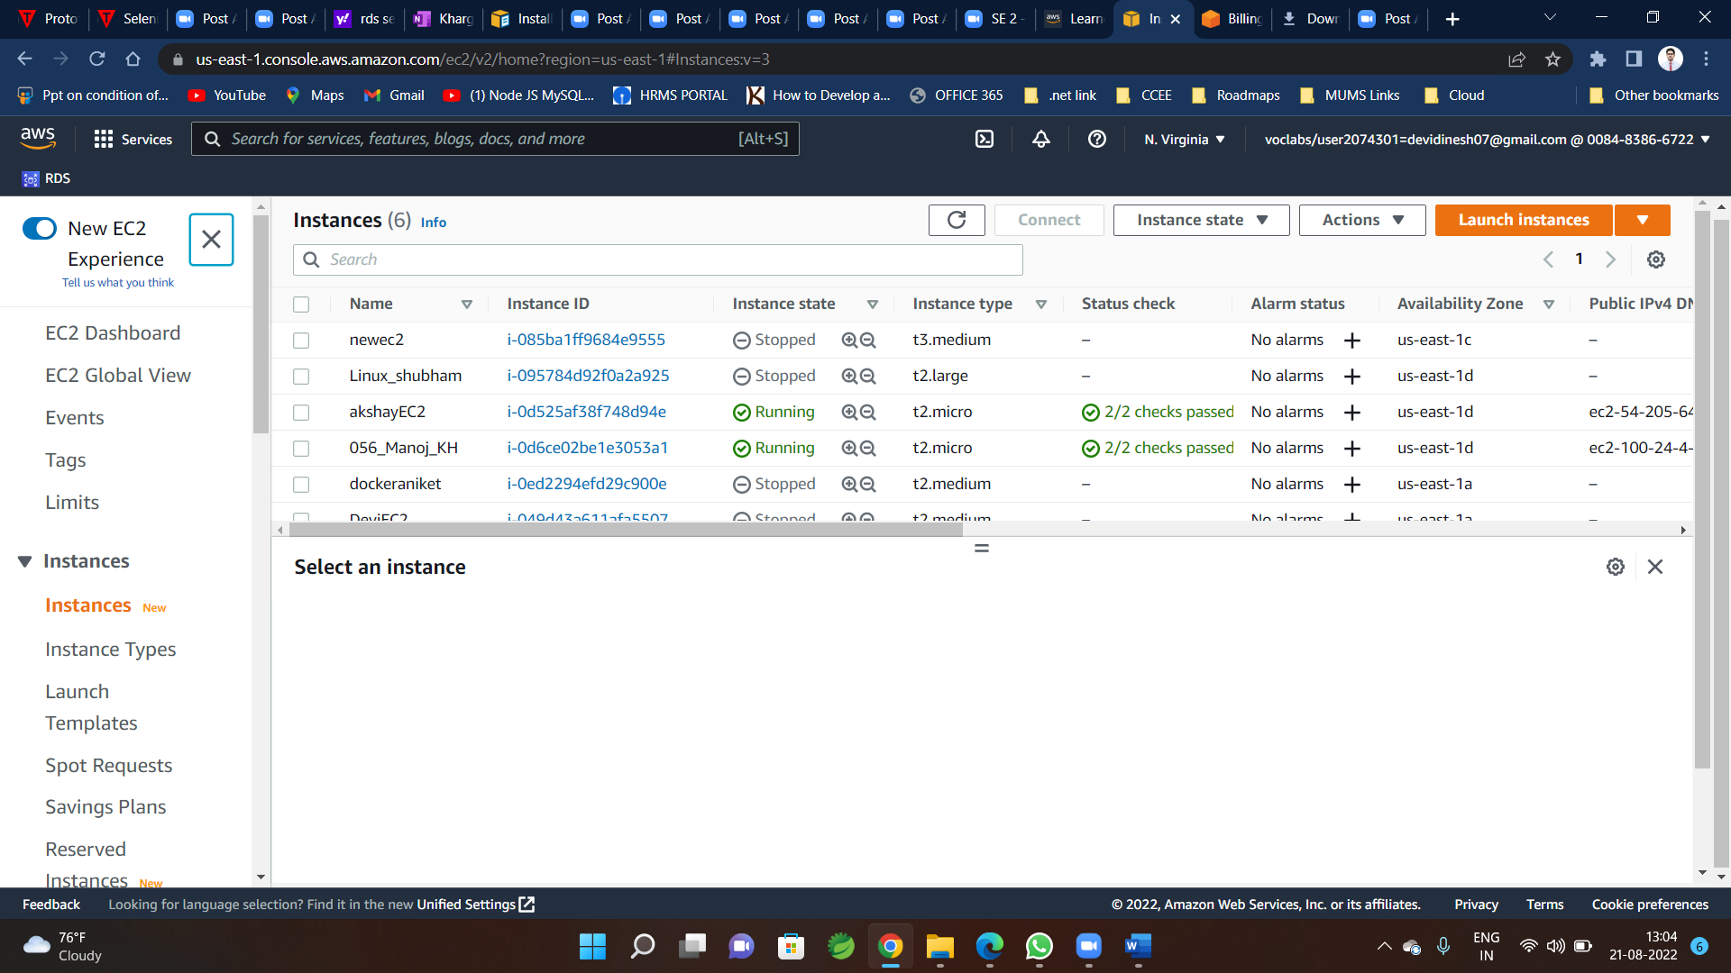

**Or you can go here from instance🡪**

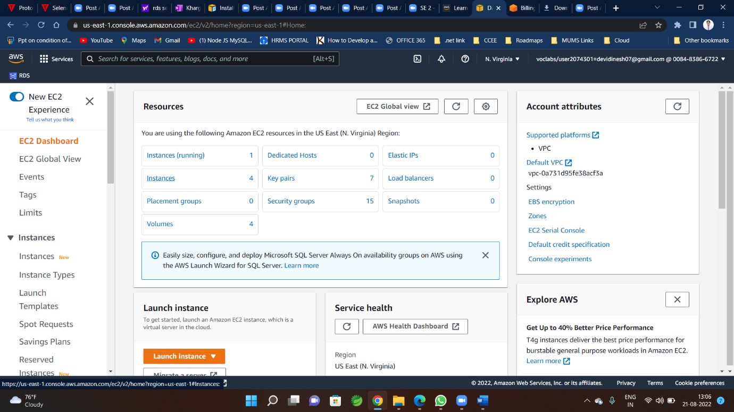

**Step-3**

**Select checkbox for instance to be started**

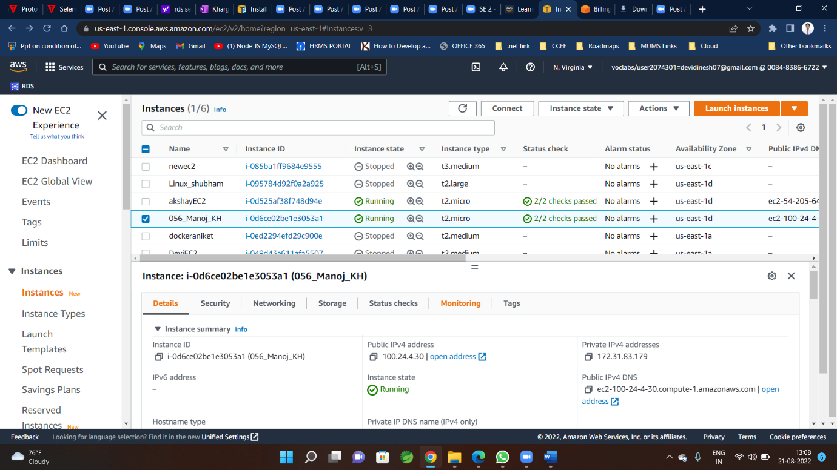

**Click on Connect**

**Step-4**

**You will be redirected to following window 🡪click on RDP client**

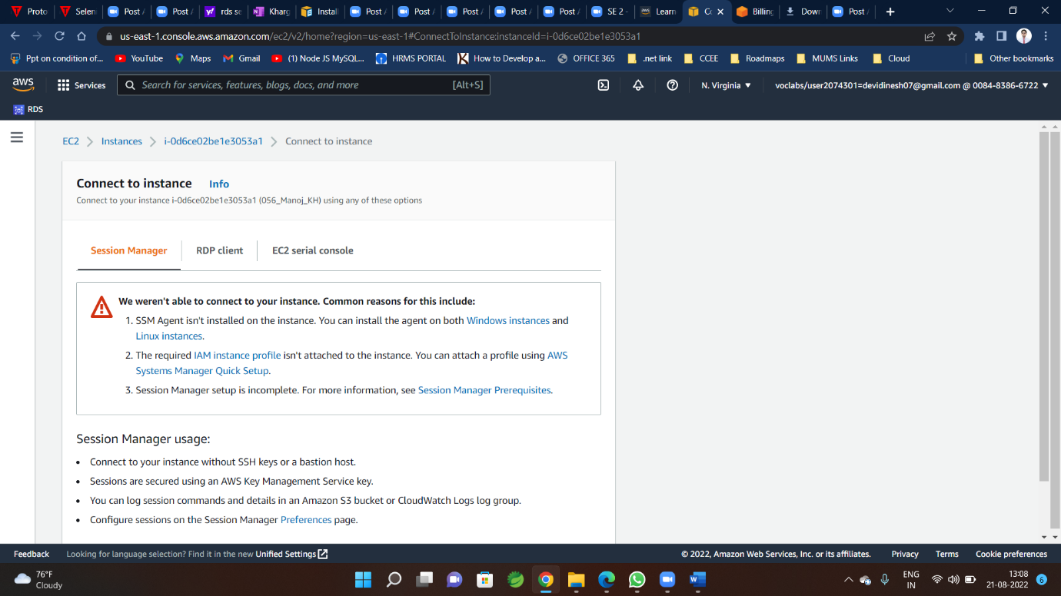

**Step-5**

**Then click on Download remote desktop file**

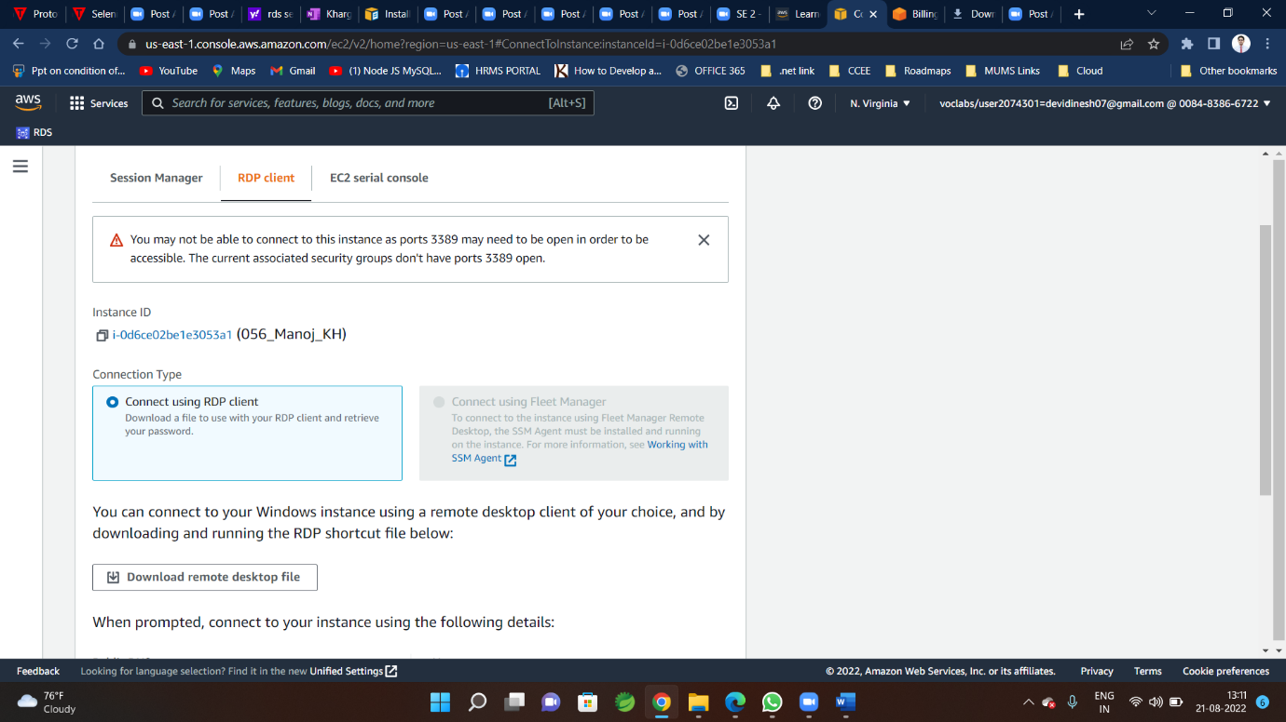

**Step-6**

**Keep downloaded file at desktop to coonect with EC2 from your PC**



**Step-7**

**Before that click on 🡪Get Password**

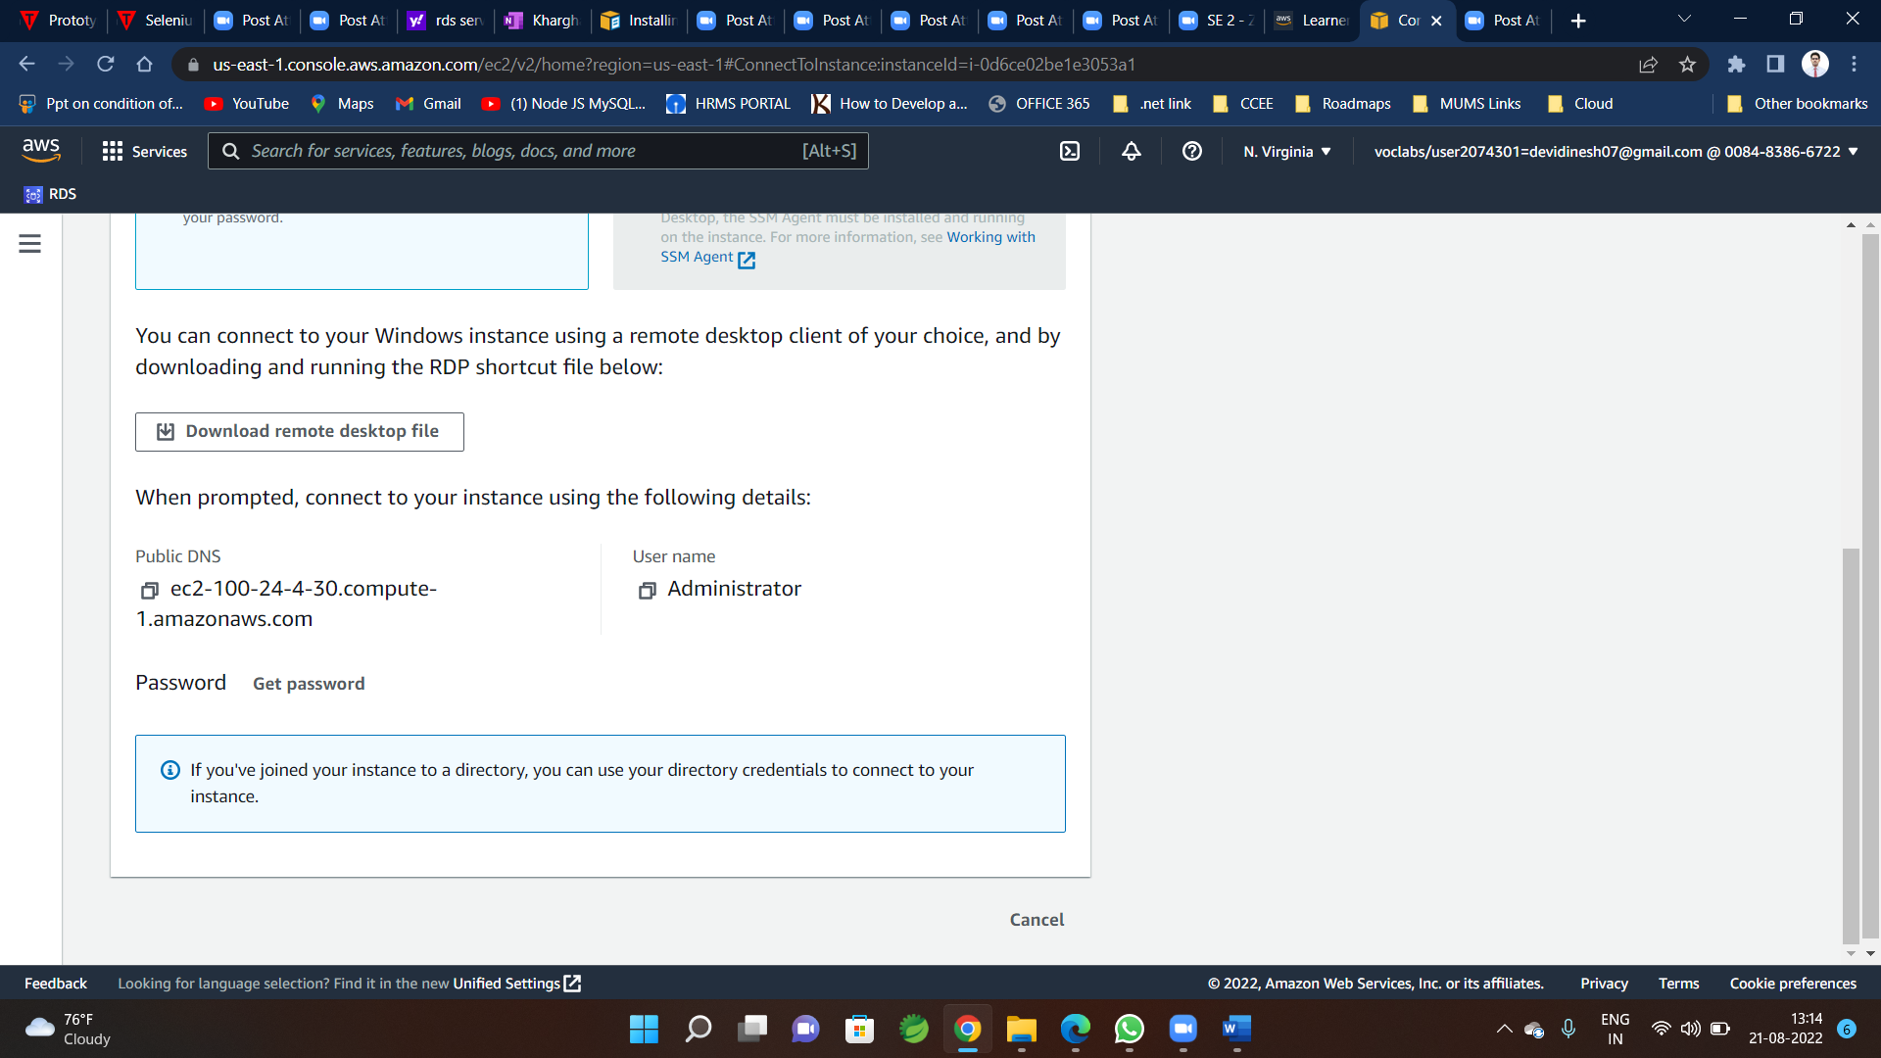

**Step-8 you will be redirected to following window**

**Browse key Pair file here(associated file name shown here)**

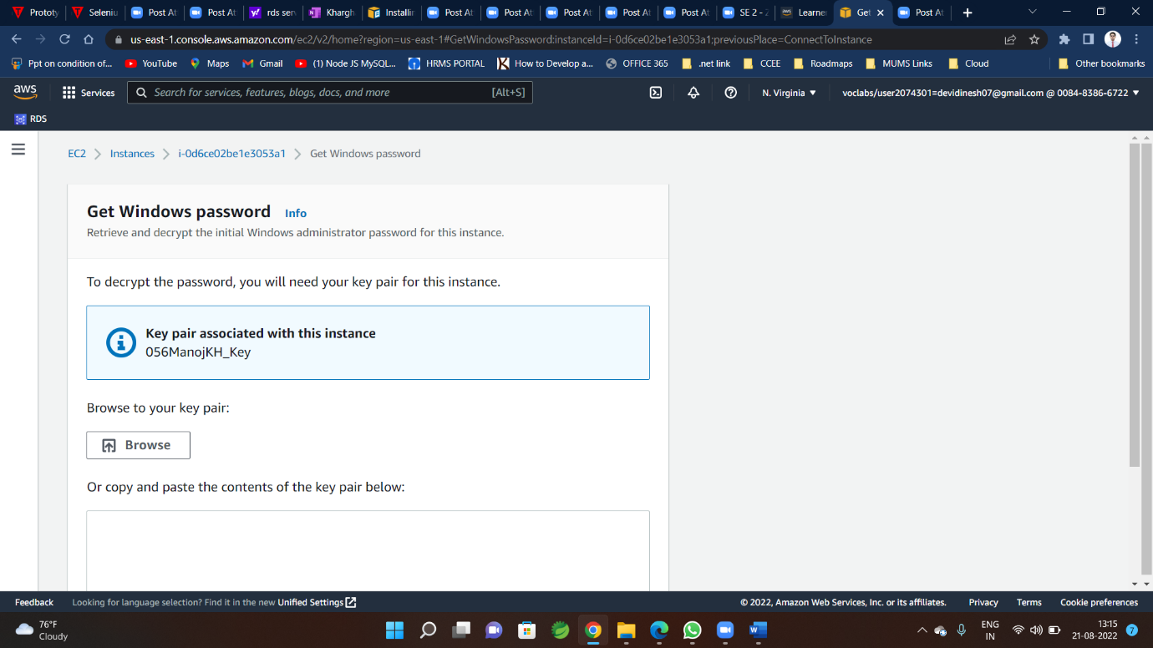

**Step-9**

**Click on Decrypt password**

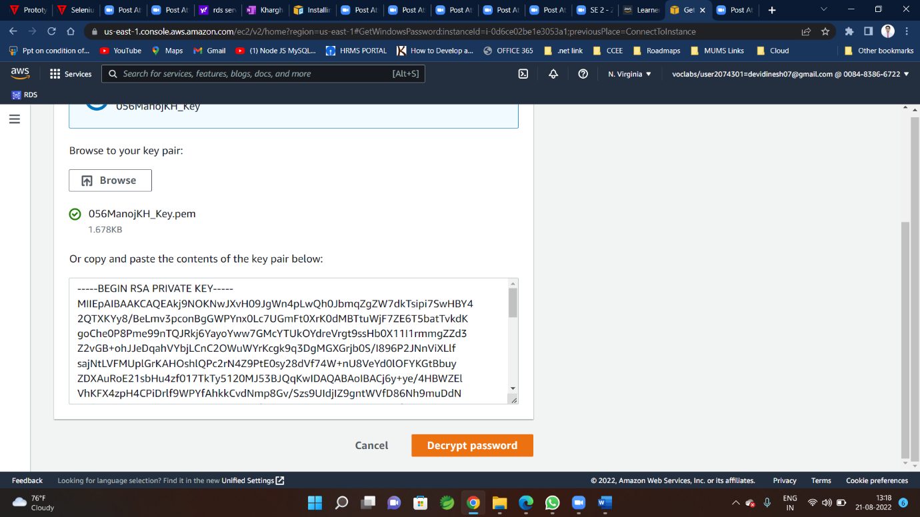

**Step-10**

**Copy this password from here**

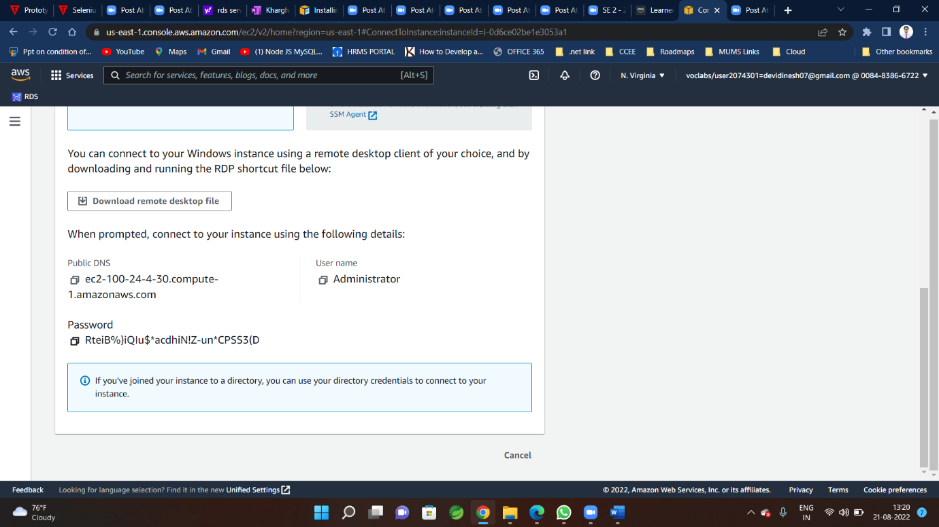

**Step-11**

**Now click on RDP client file you already downloaded in your PC and click on connect**

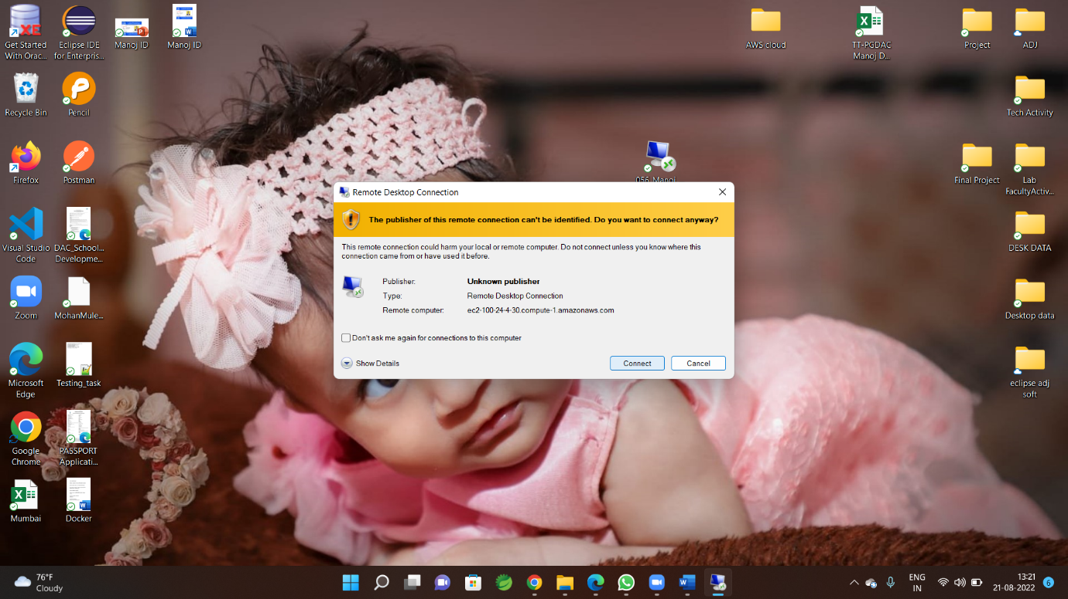

**Step-12**

**Enter Your Credentials Here**

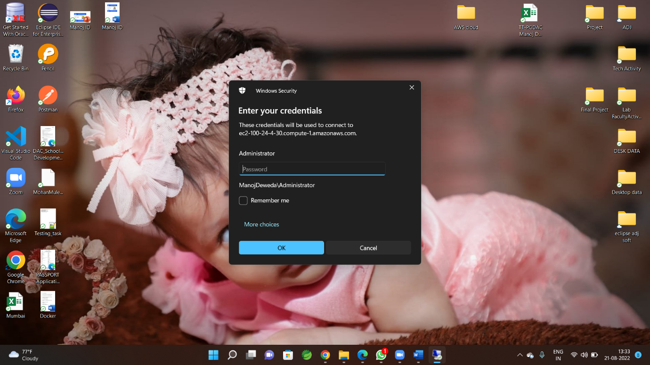

**Step-13**

**Warning shown click yes**

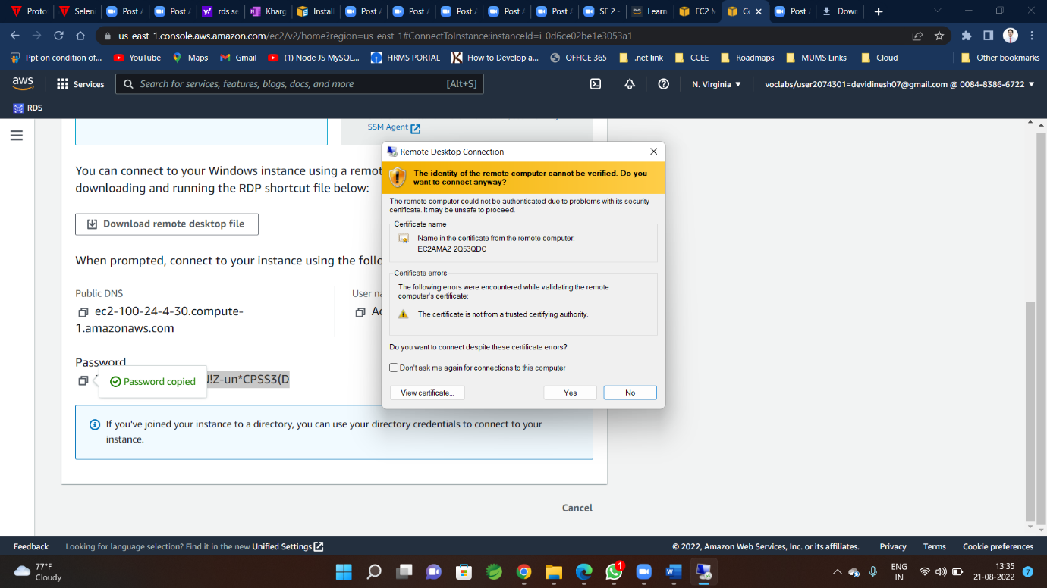

**Step-14**

**You will enter inside EC2**

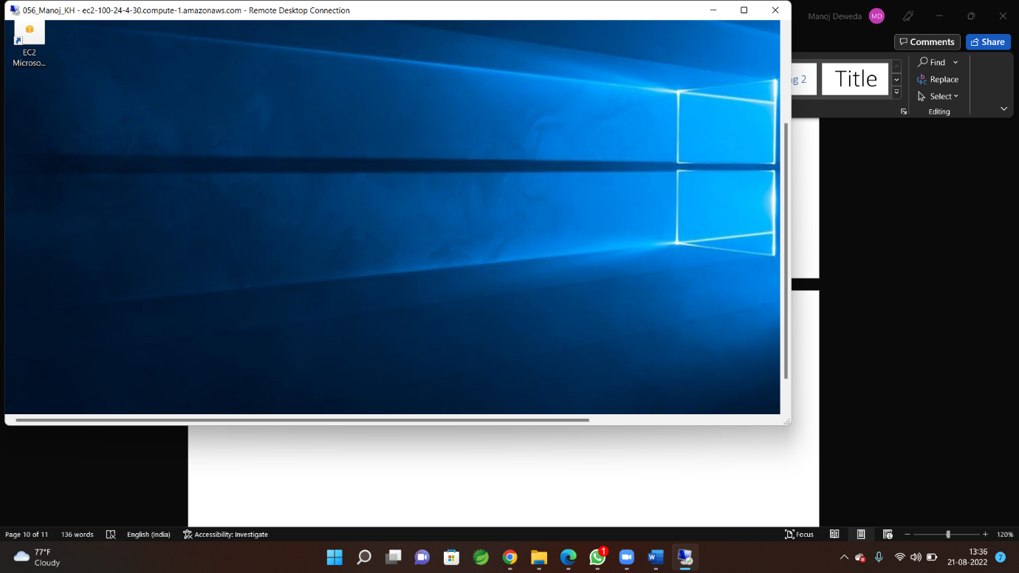

**Ab Yaha Machana start karo**